**Community Newsletter**

**West Way, Block A**

**February 2023**

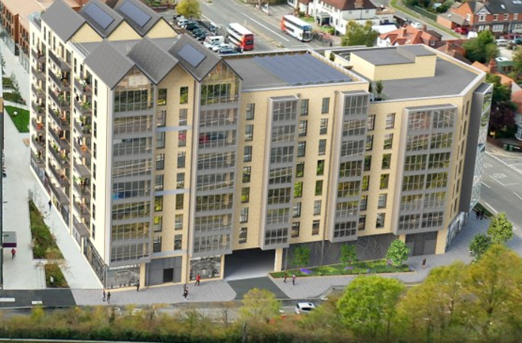

Dear Resident / Business,

Gilbert-Ash are currently progressing well on site at the Block A Westway development in Botley since we took possession on 28th November 2022.

**Works Update**

We have recently completed the piling operation, whereby 357nr reinforced concrete cores were formed to a dept of 19 meters into the ground. Our piling rig has now been removed from site and further excavators have now been employed on site to commence main drainage, foundations which I’m delighted to say is all progressing at a good pace.

We had a few challenges with the low temperatures but hopefully we are over the worst and look forward to the better weather approaching.

We are currently in the process of establishing our site welfare/office area within the site which will stay in position for the majority of the build, this set-up will provide a clean and safe environment for our team to work.

|  |  |
| --- | --- |
| **Cabins consist of**:  1 x Reception Cabin  1 x 5/1 Toilet  2 x Offices  2 x Drying rooms  2 x Canteens  1 x Meeting room |  |

**Upcoming works**

We are looking to progress with our ground works and commence the new concrete frame. We will also be installing our tower crane within our site boundaries shortly. This installation will be closely monitored by a specialist installation team. All works relating to this will be carried out from within our site to ensure as little (if any) disruption caused to the surrounding area as possible.

|  |  |
| --- | --- |
| Crane Location | Tower crane erected by mobile crane. |
|  |  |

Over the coming months, we will be working on the below:

1. Completing the pile caps and ground beams/ foundations.
2. Progressing the below ground drainage and ducts.
3. Progressing the ground floor slab.

Gilbert-Ash have an open door policy on site, and we are always available to our neighbours to answer questions you may have. It is our intention to progress our works and ensure the build journey as painless as possible for all.

**Lastly, I would like to take this opportunity to thank each and every one of you for taking the time to read our newsletter.**

**Contact details:**

|  |  |  |
| --- | --- | --- |
| Sandra | 07702 867 830 | Sandra.Duggan@gilbert-ash.co.uk |
| Jim | 07736 270 893 | James.Trustram@gilbert-ash.co.uk |
| Damien | 07971 005 057 | mckenna@gilbert-ash.co.uk |

|  |  |
| --- | --- |
| **London Office**  9 Empire Square  Tabard Street  London  SE1 4NA  +44 (0) 20 7403 3031  [london@gilbert-ash.co.uk](mailto:london@gilbert-ash.co.uk)  [view on google maps](https://www.google.co.uk/maps/place/Gilbert+-+Ash/%4051.5000386,-0.0930414,17z/data=!3m1!4b1!4m5!3m4!1s0x48760359170933e9:0xb5da0138d47e4fc3!8m2!3d51.5000386!4d-0.0908527) | **Belfast Office**  60 Boucher Place  Belfast  BT12 6HT  +44 (0) 28 9066 4334  [belfast@gilbert-ash.co.uk](mailto:belfast@gilbert-ash.co.uk)  [view on google maps](https://www.google.com/maps/place/Gilbert-Ash/%4054.577988,-5.962712,15z/data=!4m2!3m1!1s0x0:0x1b3405f53782fe5d?hl=en) |

